App:Multihreading
BÀI 1 : Viết một ứng dụng MultiThread sử dụng Message.
a) Mô tả ứng dụng
- Ứng dụng có một button Start. Khi user nhấn vào Start, thread mới sẽ khởi chạy.
- Trong thread mới sẽ phát sinh ngẫu nhiên một số từ 0 đến 100 đồng thời tăng biến đếm global intTest lên một giá trị.
- Thread sẽ gửi message chứa các dữ liệu trên. UI thread sẽ sử dụng Handler để nhận message và cập nhật giao diện.
Xây dựng giao diện:
MainActivity: nơi thêm hoàn thiện các hàm findViewBylds , initVariables, initBgThread, và override onCreate/onStart/onStop.
Code MainActivity
package com.example.multithreading;

import android.os.Bundle;
import android.os.Handler;
import android.os.Looper;
import android.os.Message;
import android.view.View;
import android.widget.Button;
import android.widget.ProgressBar;
import android.widget.TextView;

import androidx.appcompat.app.AppCompatActivity;

import java.util.Random;

public class MainActivity extends AppCompatActivity {
private ProgressBar pbFirst, pbSecond;
private TextView tvMsgWorking, tvMsgReturned;
private boolean isRunning;
private int MAX_SEC;
private int intTest;
private Thread bgThread;
private Handler handler;
private Button btnStart;

@Override
protected void onCreate(Bundle savedInstanceState) {
super.onCreate(savedInstanceState);
setContentView(R.layout.activity_main);
findViewByIds();
initVariables();

btnStart.setOnClickListener(new View.OnClickListener() {
@Override
public void onClick(View v) {
isRunning = true;
pbFirst.setVisibility(View.VISIBLE);
pbSecond.setVisibility(View.VISIBLE);
btnStart.setVisibility(View.GONE);
if (bgThread != null) bgThread.start();
}
});
}

private void findViewByIds() {
pbFirst = findViewById(R.id.pb_first);
pbSecond = findViewById(R.id.pb_second);
tvMsgWorking = findViewById(R.id.tv_working);
tvMsgReturned = findViewById(R.id.tv_return);
btnStart = findViewById(R.id.btn_start);
}

private void initVariables() {
isRunning = false;
MAX_SEC = 20;
intTest = 1;
pbFirst.setMax(MAX_SEC);
pbFirst.setProgress(0);
pbFirst.setVisibility(View.GONE);
pbSecond.setVisibility(View.GONE);

handler = new Handler(Looper.getMainLooper()) {
@Override
public void handleMessage(Message msg) {
String returnedValue = (String) msg.obj;
tvMsgReturned.setText(getString(R.string.returned_by_bg_thread) + returnedValue);
pbFirst.incrementProgressBy(2);
if (pbFirst.getProgress() >= MAX_SEC) {
tvMsgReturned.setText(getString(R.string.done_background_thread_has_been_stopped));
tvMsgWorking.setText(getString(R.string.done));
pbFirst.setVisibility(View.GONE);
pbSecond.setVisibility(View.GONE);
btnStart.setVisibility(View.VISIBLE);
isRunning = false;
} else {
tvMsgWorking.setText(getString(R.string.working) + " " + pbFirst.getProgress());
}
}
};
}

private void initBgThread() {
bgThread = new Thread(new Runnable() {
@Override
public void run() {
try {
for (int i = 0; i < MAX_SEC && isRunning; i++) {
Thread.sleep(1000);
Random rnd = new Random();
String data = "Thread value: " + rnd.nextInt(101);
data += getString(R.string.global_value_seen) + " " + intTest;
intTest++;
if (isRunning) {
Message msg = handler.obtainMessage(1, data);
handler.sendMessage(msg);
}
}
} catch (Throwable t) { /* ignore */ }
}
});
}

@Override
protected void onStart() {
super.onStart();
initBgThread();
}

@Override
protected void onStop() {
super.onStop();
isRunning = false;
}
// ...existing code...
}
Code dimens.xml
<resources>
<dimen name="margin_base">5dp</dimen>
<dimen name="text_small">14sp</dimen>
<dimen name="text_medium">16sp</dimen>
<dimen name="text_medium_large">18sp</dimen>
<dimen name="text_large">20sp</dimen>
</resources>
Code String.xml
<resources>
<string name="app_name">Multithreading</string>
<string name="start">Start</string>
<string name="returned_by_bg_thread">Returned by background thread: \n\n</string>
<string name="done_background_thread_has_been_stopped">Done \n\nBackground thread has been stopped</string>
<string name="done">Done</string>
<string name="working">Working...</string>
<string name="global_value_seen">\n global value seen by all thread</string>
</resources>

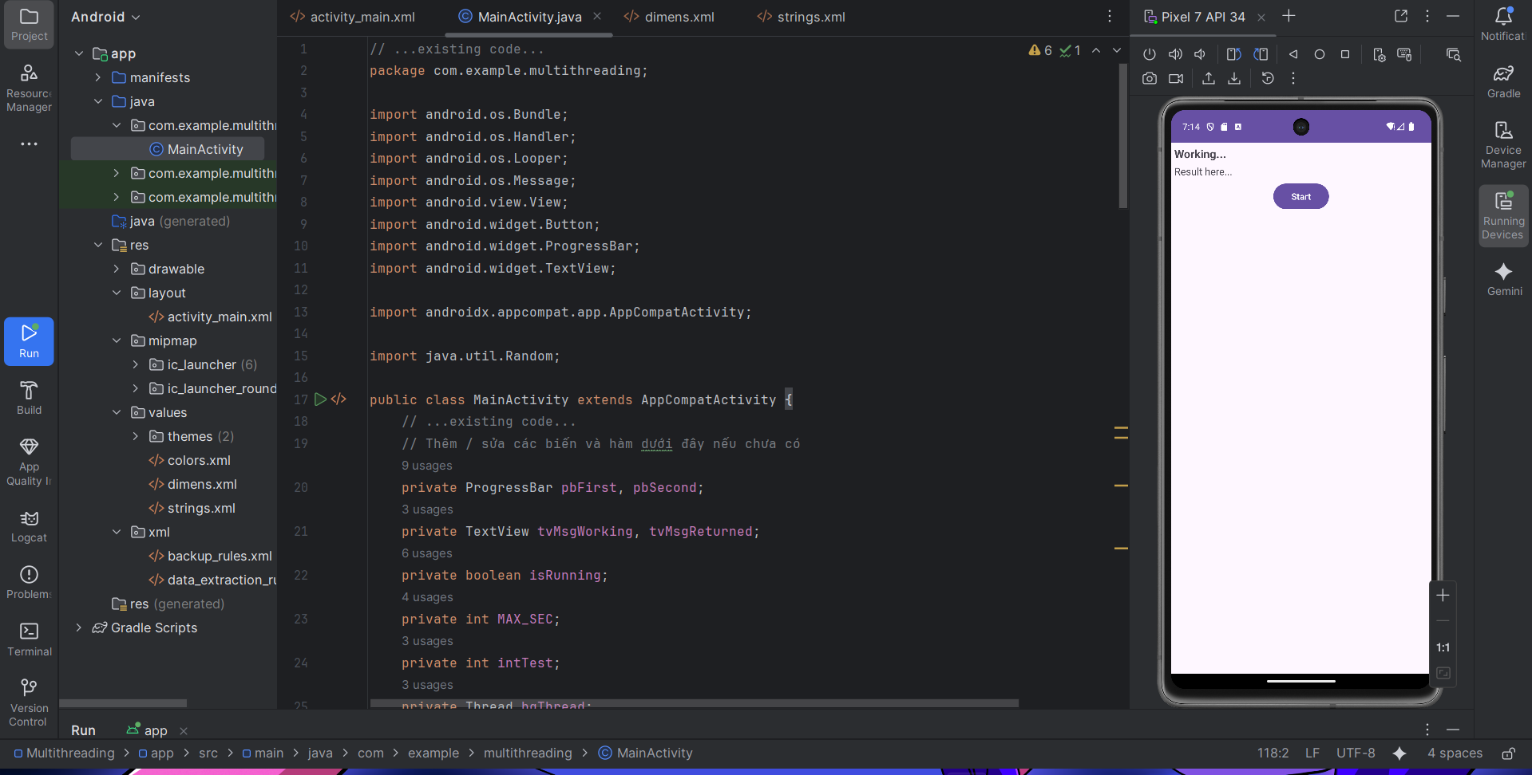
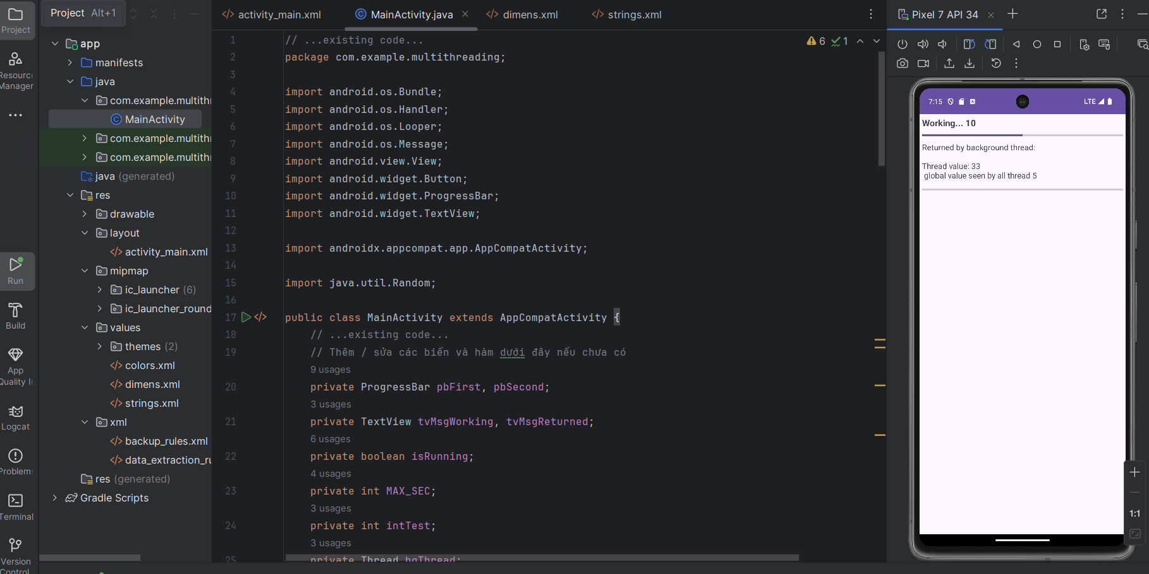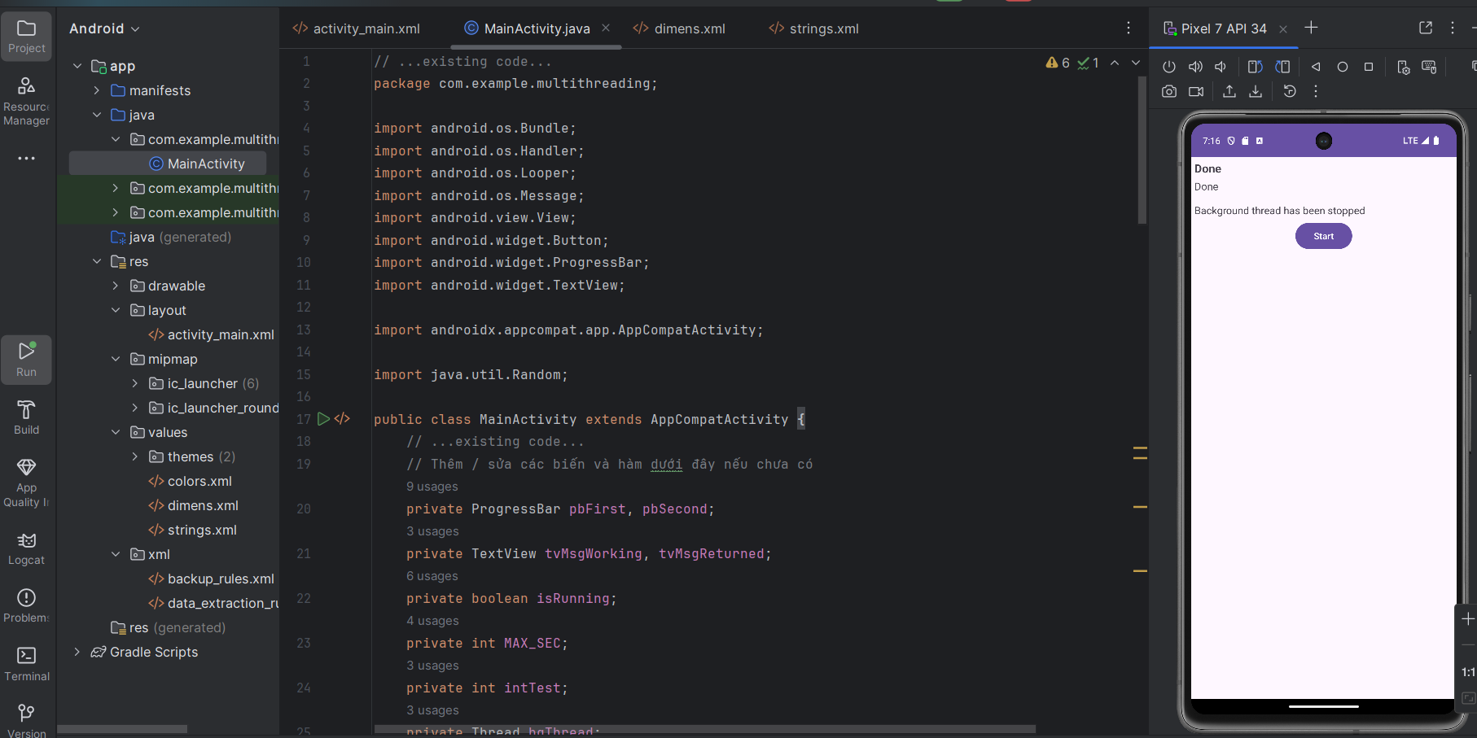

Bài 2 : Viết ứng dụng MultiThread sử dụng Post
a) Mô tả ứng dụng
- Ứng dụng khởi chạy 1 thread mới. Thread mới sẽ chạy 2 runnable: bgRunnable và fgRunnable cùng cập nhật giá trị của biến globalValue.
- Trong đó, bgRunnable cứ sau 1s sẽ tăng giá trị biến globalValue lên 1. Còn fgRunnable mỗi lần sẽ tăng giá trị biến globalValue lên 100.
- Khi người dùng nhập data vào etInput và nhấn Execute thì data sẽ được hiện lên dưới dạng Toast.
Xây dựng giao diện
Code ActivityMain
package com.example.multithreading;
import android.os.Bundle;
import android.os.Handler;
import android.os.Looper;
import android.os.Message;
import android.util.Log;
import android.view.View;
import android.widget.Button;
import android.widget.EditText;
import android.widget.ProgressBar;
import android.widget.TextView;
import android.widget.Toast;
import androidx.appcompat.app.AppCompatActivity;
import java.util.Random;
public class MainActivity extends AppCompatActivity {
private ProgressBar pbFirst, pbSecond, pbWaiting;
private TextView tvMsgWorking, tvMsgReturned, tvTopCaption;
private Button btnStart, btnExecute;
private EditText etInput;
private Handler handler;
private Thread bgThread;
private boolean isRunning;
private int MAX_SEC, intTest;
@Override
protected void onCreate(Bundle savedInstanceState) {
super.onCreate(savedInstanceState);
setContentView(R.layout.activity_main);
findViewByIds();
initVariables();
btnStart.setOnClickListener(new View.OnClickListener() {
@Override
public void onClick(View v) {
isRunning = true;
pbFirst.setVisibility(View.VISIBLE);
pbSecond.setVisibility(View.VISIBLE);
btnStart.setVisibility(View.GONE);
tvMsgReturned.setText("");
tvMsgWorking.setText(getString(R.string.working) + " 0");
// Bắt đầu thread nền
if (bgThread == null || !bgThread.isAlive()) {
initBgThread();
bgThread.start();
}
}
});
// Lab-Post: chỉ để minh họa, không dùng trong bài
btnExecute.setOnClickListener(new View.OnClickListener() {
@Override
public void onClick(View v) {
String input = etInput.getText().toString();
Toast.makeText(MainActivity.this, input, Toast.LENGTH_SHORT).show();
}
});
}
private void findViewByIds() {
pbFirst = findViewById(R.id.pb_first);
pbSecond = findViewById(R.id.pb_second);
tvMsgWorking = findViewById(R.id.tv_working);
tvMsgReturned = findViewById(R.id.tv_return);
btnStart = findViewById(R.id.btn_start);
// Lab-Post views (nếu layout có)
tvTopCaption = findViewById(R.id.tv_top_caption);
pbWaiting = findViewById(R.id.pb_waiting);
etInput = findViewById(R.id.et_input);
btnExecute = findViewById(R.id.btn_execute);
// Fail fast nếu view bị thiếu — giúp xác định lỗi layout ngay lập tức
StringBuilder missing = new StringBuilder();
if (pbFirst == null) missing.append(" pb_first");
if (pbSecond == null) missing.append(" pb_second");
if (tvMsgWorking == null) missing.append(" tv_working");
if (tvMsgReturned == null) missing.append(" tv_return");
if (btnStart == null) missing.append(" btn_start");
if (missing.length() > 0) {
throw new IllegalStateException("Missing view ids in layout:" + missing.toString() + ". Check app/src/main/res/layout/activity_main.xml");
}
}
private void initVariables() {
isRunning = false;
MAX_SEC = 20;
intTest = 1;
// bảo đảm pbFirst không null trước khi dùng
if (pbFirst == null) {
throw new IllegalStateException("pbFirst is null. Did you call findViewByIds() after setContentView(...) and does activity_main.xml contain @id/pb_first?");
}
pbFirst.setMax(MAX_SEC);
pbFirst.setProgress(0);
pbFirst.setVisibility(View.GONE);
if (pbSecond != null) pbSecond.setVisibility(View.GONE);
// Handler và handleMessage phải ở đây (không trong findViewByIds)
handler = new Handler(Looper.getMainLooper()) {
@Override
public void handleMessage(Message msg) {
// đảm bảo msg.obj không null và là String
Object o = msg.obj;
String returnedValue = o != null ? String.valueOf(o) : "";
tvMsgReturned.setText(getString(R.string.returned_by_bg_thread) + returnedValue);
// cập nhật progress
pbFirst.incrementProgressBy(2);
if (pbFirst.getProgress() >= MAX_SEC) {
tvMsgReturned.setText(getString(R.string.done_background_thread_has_been_stopped));
tvMsgWorking.setText(getString(R.string.done));
pbFirst.setVisibility(View.GONE);
pbSecond.setVisibility(View.GONE);
btnStart.setVisibility(View.VISIBLE);
isRunning = false;
} else {
tvMsgWorking.setText(getString(R.string.working) + " " + pbFirst.getProgress());
}
}
};
}
private void initBgThread() {
// Tạo mới Random trong thread nền; không dùng new Random() trong handler
bgThread = new Thread(new Runnable() {
@Override
public void run() {
Random rnd = new Random();
try {
for (int i = 0; i < MAX_SEC && isRunning; i++) {
Thread.sleep(1000);
// Sinh random trong bg thread và gửi Message
String data = "Thread value: " + rnd.nextInt(101);
data += getString(R.string.global_value_seen) + " " + intTest;
intTest++;
if (isRunning && handler != null) {
Message m = handler.obtainMessage(1, data);
handler.sendMessage(m);
}
}
} catch (InterruptedException ie) {
Thread.currentThread().interrupt();
} catch (Throwable t) {
Log.e("initBgThread", "bg thread error", t);
}
}
});
}
}

Code activity_main.xml
<?xml version="1.0" encoding="utf-8"?>
<ScrollView xmlns:android="http://schemas.android.com/apk/res/android"
android:layout_width="match_parent"
android:layout_height="match_parent"
android:padding="@dimen/margin_base">
<LinearLayout
android:layout_width="match_parent"
android:layout_height="wrap_content"
android:orientation="vertical">
<!-- Lab-Post top caption -->
<TextView
android:id="@+id/tv_top_caption"
android:layout_width="match_parent"
android:layout_height="wrap_content"
android:textSize="@dimen/text_medium" />
<ProgressBar
android:id="@+id/pb_waiting"
style="?android:attr/progressBarStyleHorizontal"
android:layout_width="match_parent"
android:layout_height="wrap_content"
android:layout_marginTop="@dimen/margin_base" />
<EditText
android:id="@+id/et_input"
android:layout_width="match_parent"
android:layout_height="wrap_content"
android:hint="@string/enter_some_data_here"
android:textSize="@dimen/text_medium" />
<Button
android:id="@+id/btn_execute"
android:layout_width="wrap_content"
android:layout_height="wrap_content"
android:layout_gravity="center"
android:text="@string/execute" />
<ProgressBar
android:id="@+id/pb_first"
style="?android:attr/progressBarStyleHorizontal"
android:layout_width="match_parent"
android:layout_height="wrap_content" />
<ProgressBar
android:id="@+id/pb_second"
style="?android:attr/progressBarStyleHorizontal"
android:layout_width="match_parent"
android:layout_height="wrap_content" />
<TextView
android:id="@+id/tv_working"
android:layout_width="match_parent"
android:layout_height="wrap_content"
android:textSize="@dimen/text_medium_large"
android:text="@string/working" />
<TextView
android:id="@+id/tv_return"
android:layout_width="match_parent"
android:layout_height="wrap_content"
android:textSize="@dimen/text_medium" />
<Button
android:id="@+id/btn_start"
android:layout_width="wrap_content"
android:layout_height="wrap_content"
android:text="@string/start"
android:layout_gravity="center" />
<!-- existing Lab-Message views should remain below (if already present in layout) -->
</LinearLayout>
</ScrollView>

Code dimens.xml
<?xml version="1.0" encoding="utf-8"?>
<resources>
<dimen name="margin_base">5dp</dimen>
<dimen name="text_small">14sp</dimen>
<dimen name="text_medium">16sp</dimen>
<dimen name="text_medium_large">18sp</dimen>
<dimen name="text_large">20sp</dimen>
</resources>
Code string.xml
<resources>
<string name="app_name">Multithreading</string>
<string name="start">Start</string>
<string name="returned">Returned by background thread:\n\n</string>
<string name="done_background_thread_has_been_stopped">Done \n\nBackground thread has been stopped</string>
<string name="done">Done</string>
<string name="working">Working...</string>
<string name="global_value_seen">\n global value seen by all thread</string>
<string name="bg_work_is_over">Background work is over!</string>
<string name="execute">Execute</string>
<string name="enter_some_data_here">Enter some data here</string>

</resources>
Code ids.xml
<?xml version="1.0" encoding="utf-8"?>
<resources>
<!-- Các id phải là item rỗng (self-closing) -->
<item name="tv_return" type="id" />
<item name="pb_first" type="id" />
<item name="pb_second" type="id" />
<item name="btn_start" type="id" />
<item name="tv_working" type="id" />
<item name="tv_top_caption" type="id" />
<item name="pb_waiting" type="id" />
<item name="et_input" type="id" />
<item name="btn_execute" type="id" />
</resource

